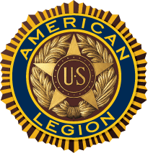
April Showers Dinner
Sunday, April 6, 2025, at 1:30 p.m.
Cumberland Post 14
695 Broad Street, Cumberland, RI 02864
Menu
Turkey w Stuffing
Salad
Mashed Potato and Gravy
Cranberry Sauce,Vegetable
Dinner Rolls, Butter, Dessert & Coffee
Donation $30:00 per ticket
For Tickets Mail Your Check Made Out To
The American Legion, C & Y Committee
PO Box 1191, Pawtucket, RI 02862
_ _ _ _ _ _ _ _ _ _ _ _ _ _ _ _ _ _ _ _ _ _ _ _ _ _ _ _ _ _ _ _ _ _ _ _ _ _ _ _

Name _________________________________________________

Number of Tickets ______ X $30:00 =$ ______________

Address__________________________________________________
__________________________________________________________

